

Assignment 2

Network Security

Soheil Shirvani 3720505



# Security Victim Machine: TCPDump Commands:

1. # ifconfig

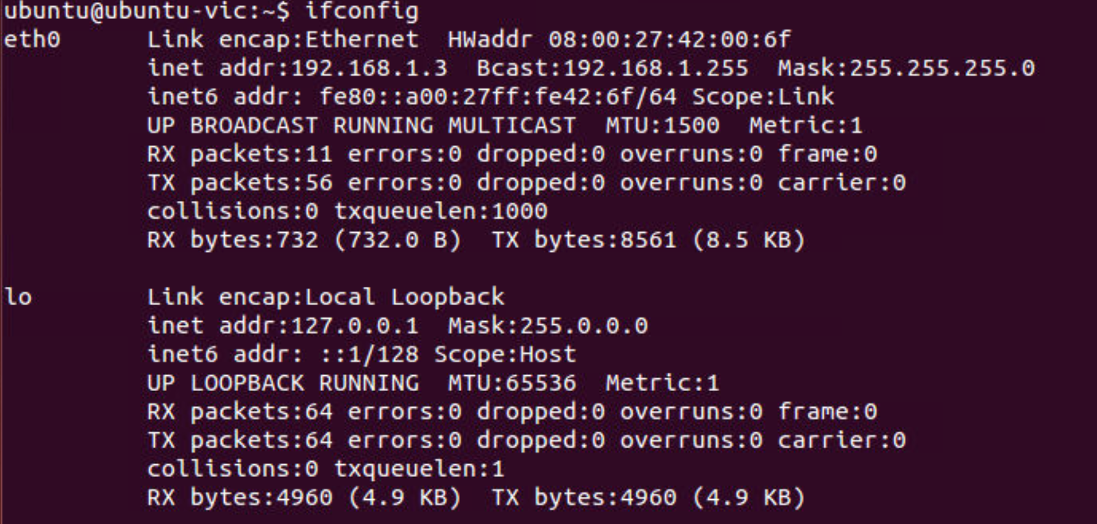

1. sudo tcpdump -i eth0

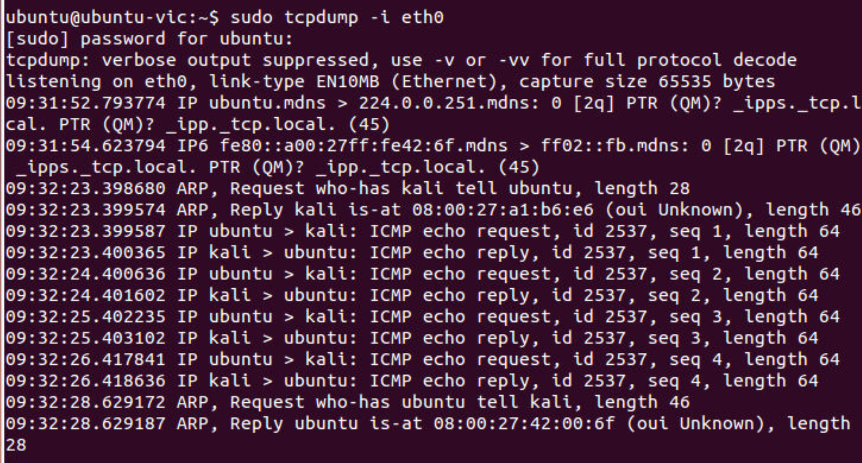

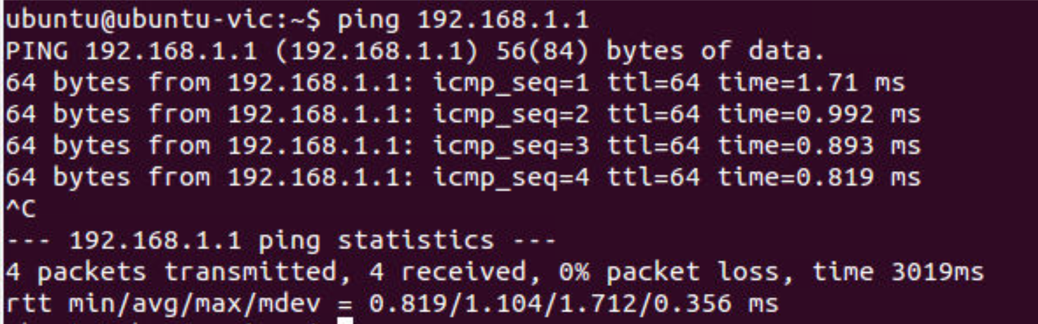

1. sudo tcpdump -I eth0 -X

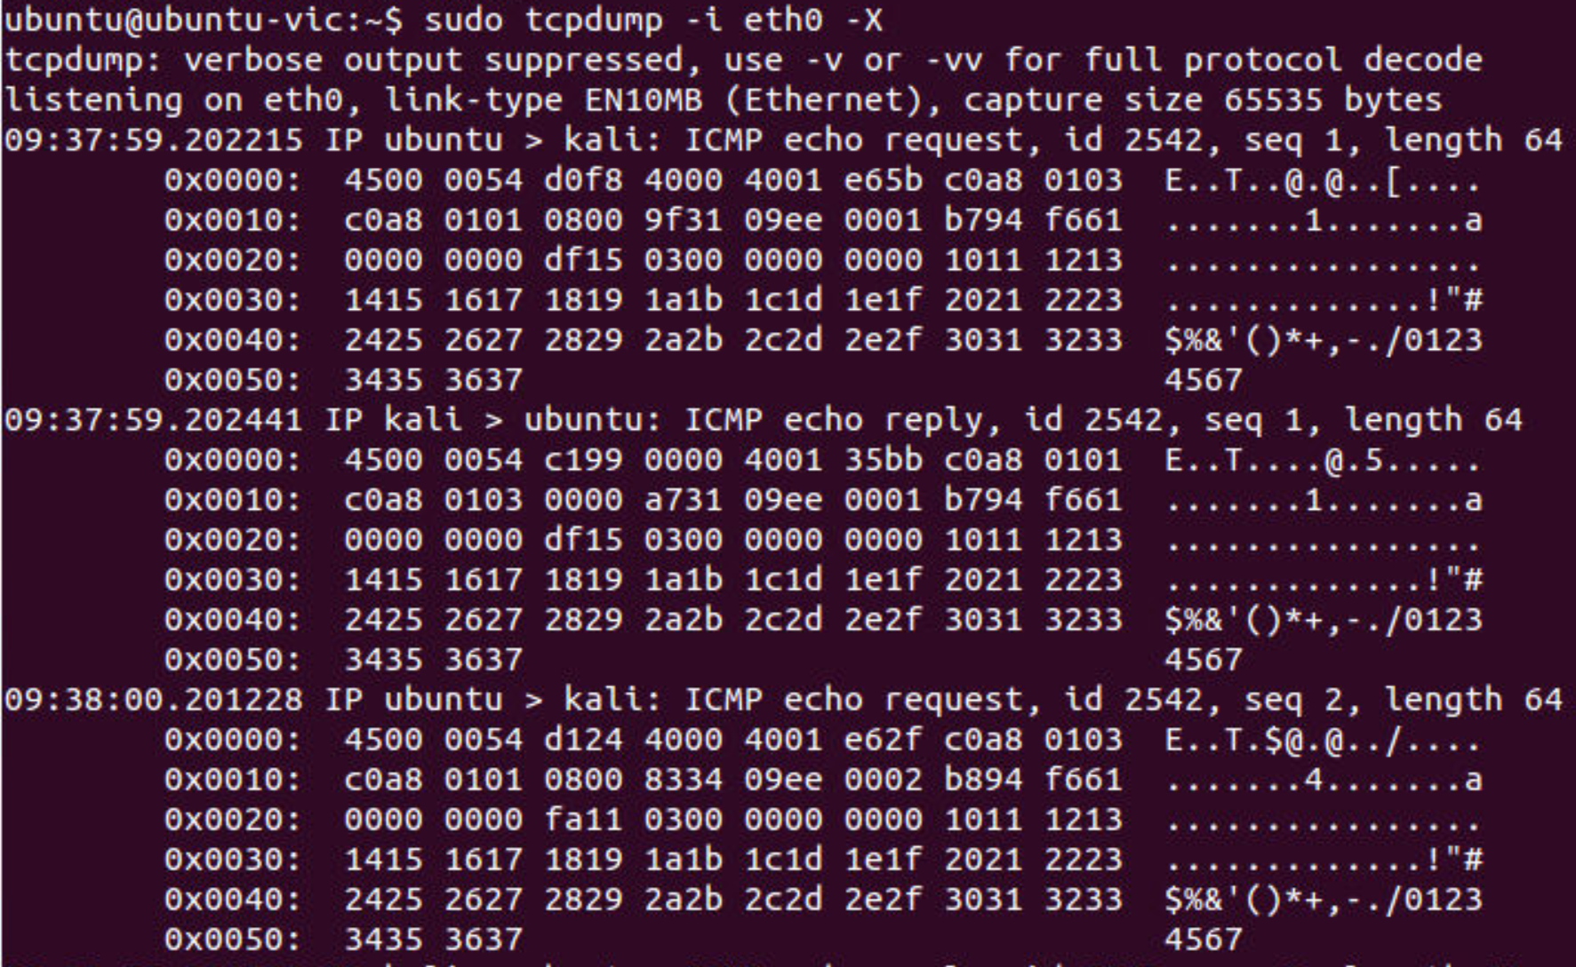

1. sudo tcpdump host 192.169.1.3

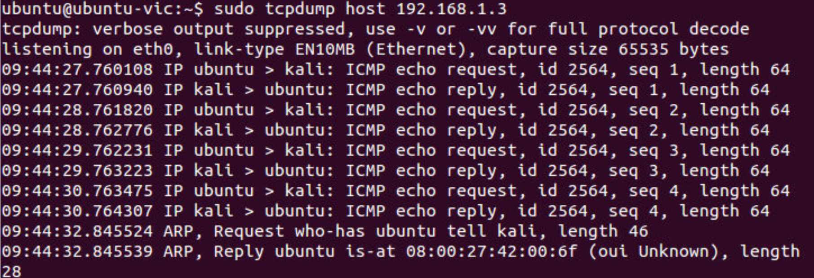

1. sudo tcpdump -i eth0 src 192.168.1.3

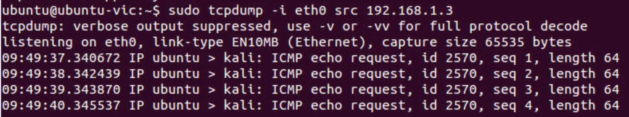

1. sudo tcpdump -i eth0 dst 192.168.1.3

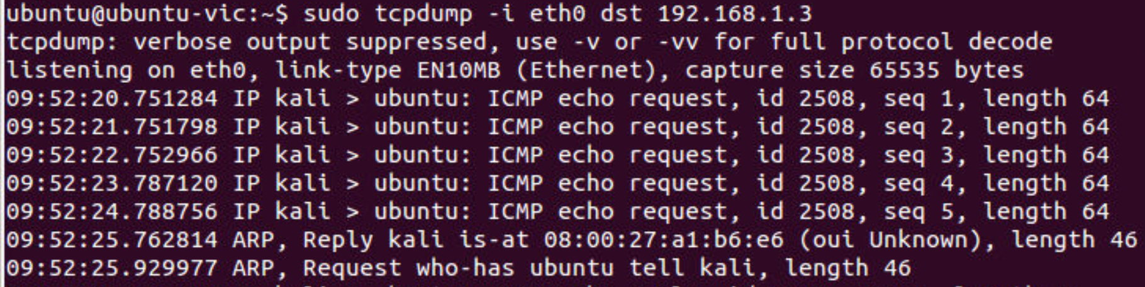

1. sudo tcpdump -i eth0 port 443

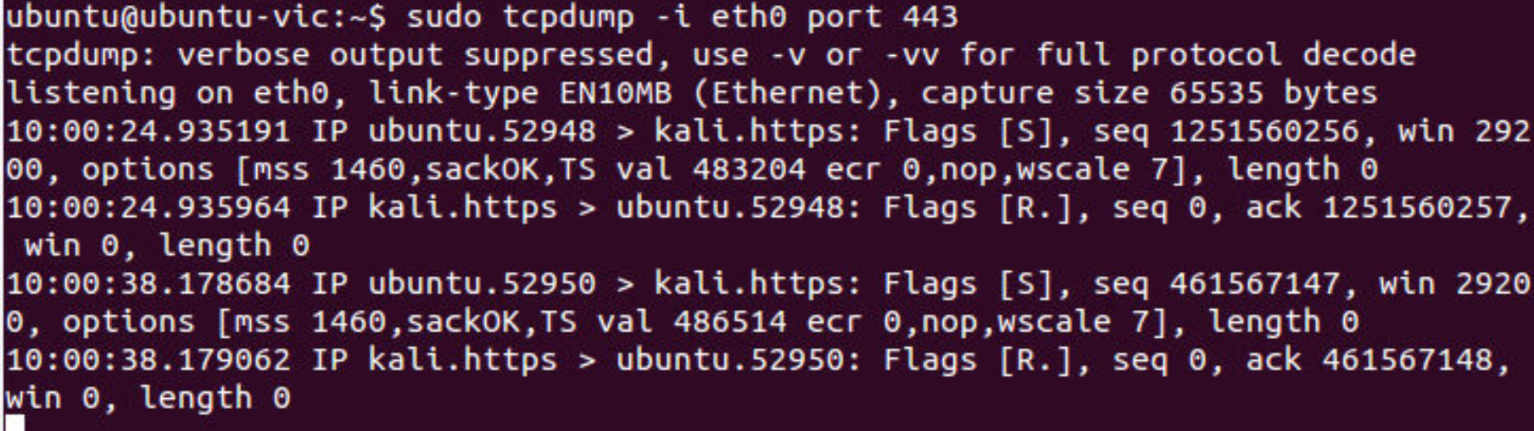

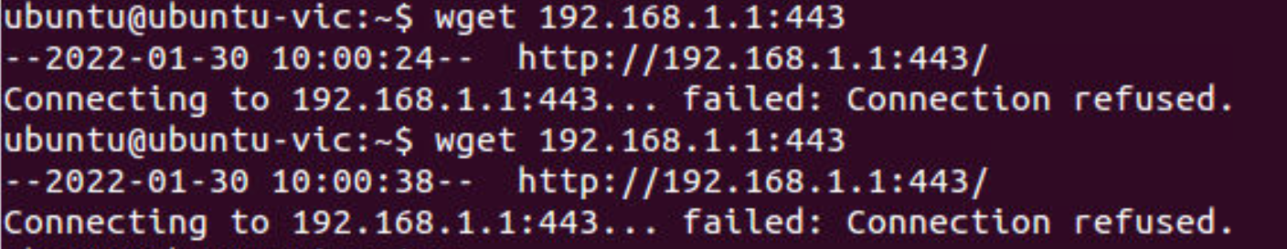

1. sudo tcpdump -i eth0 src port 443

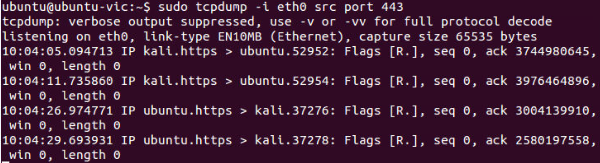

1. sudo tcpdump -i eth0 src port 443

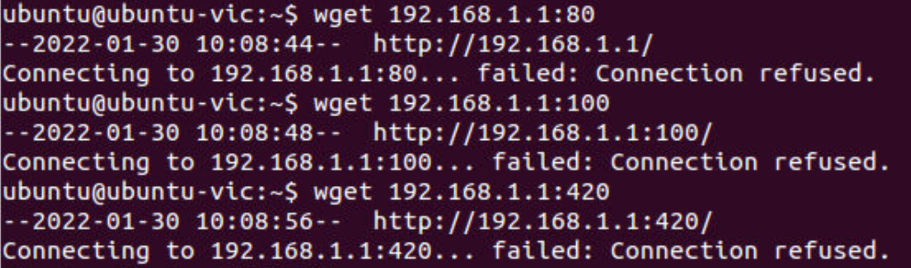

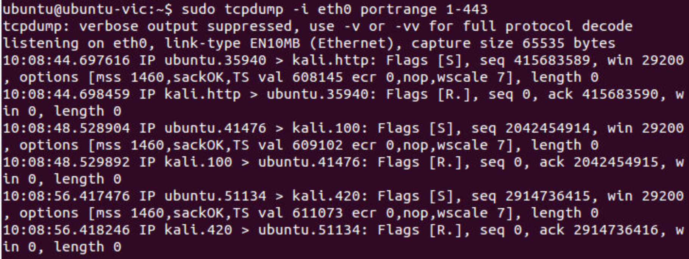

1. sudo tcpdump -i eth0 -w test.pcap



1. sudo tcpdump -i eth0 -W 2 -C 10 -w test.pcap

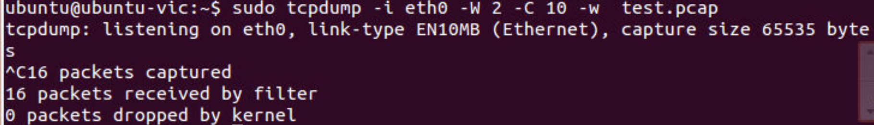

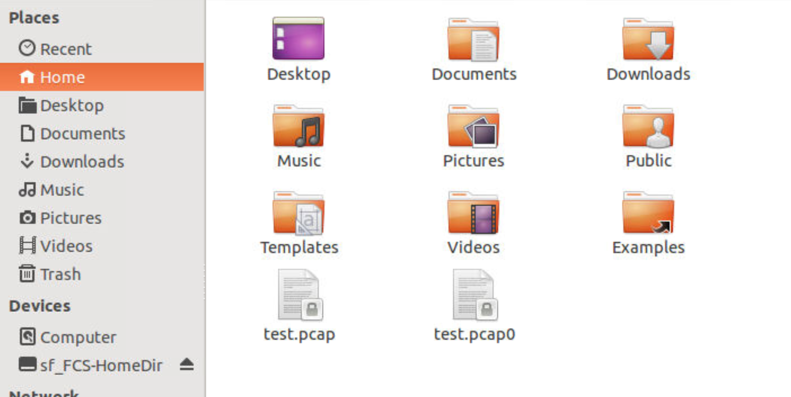

1. sudo tcpdump -r test.pcap0

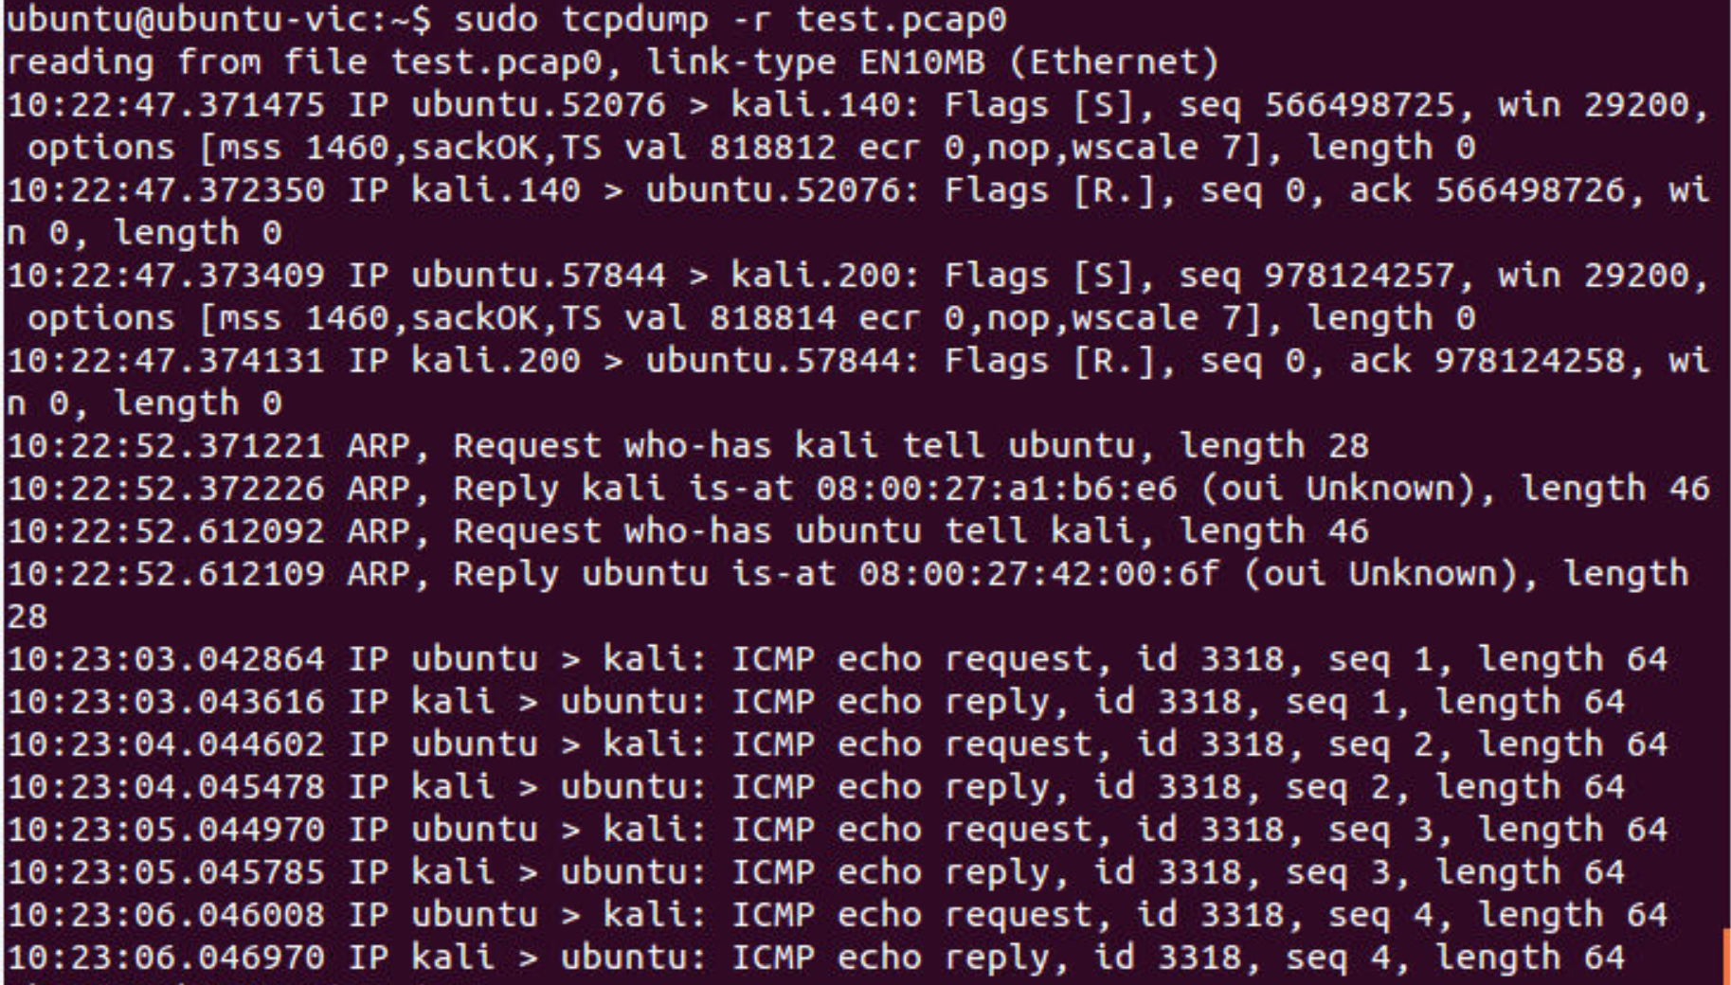

# Security Attacker Machine: WireShark Commands:

1. # ifconfig

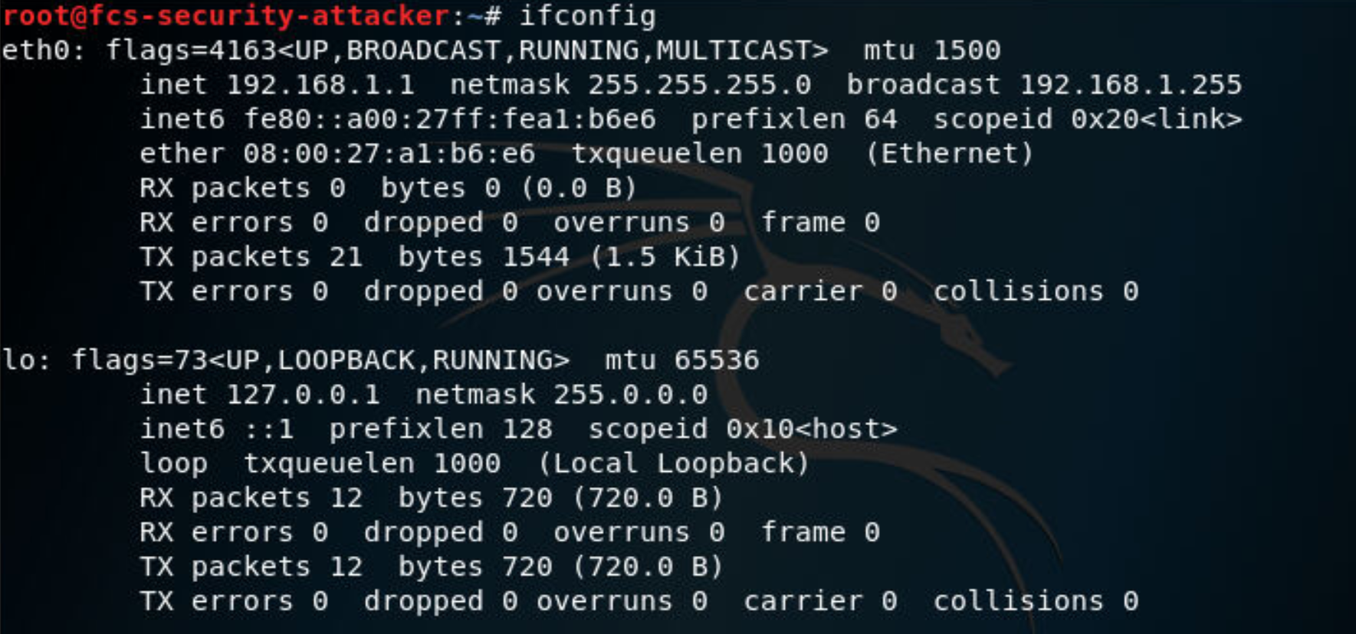

1. sudo tcpdump -i eth0 -> Wireshark -> click on eth0 on first windows

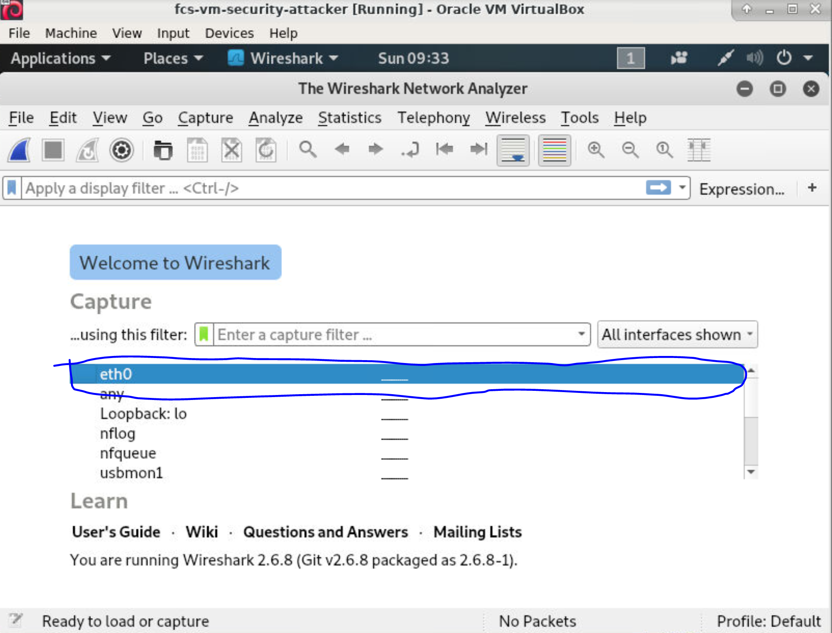

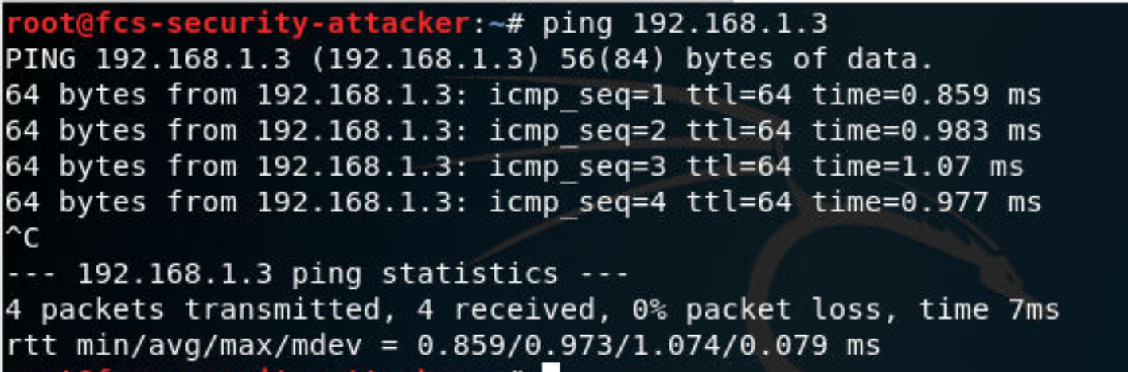

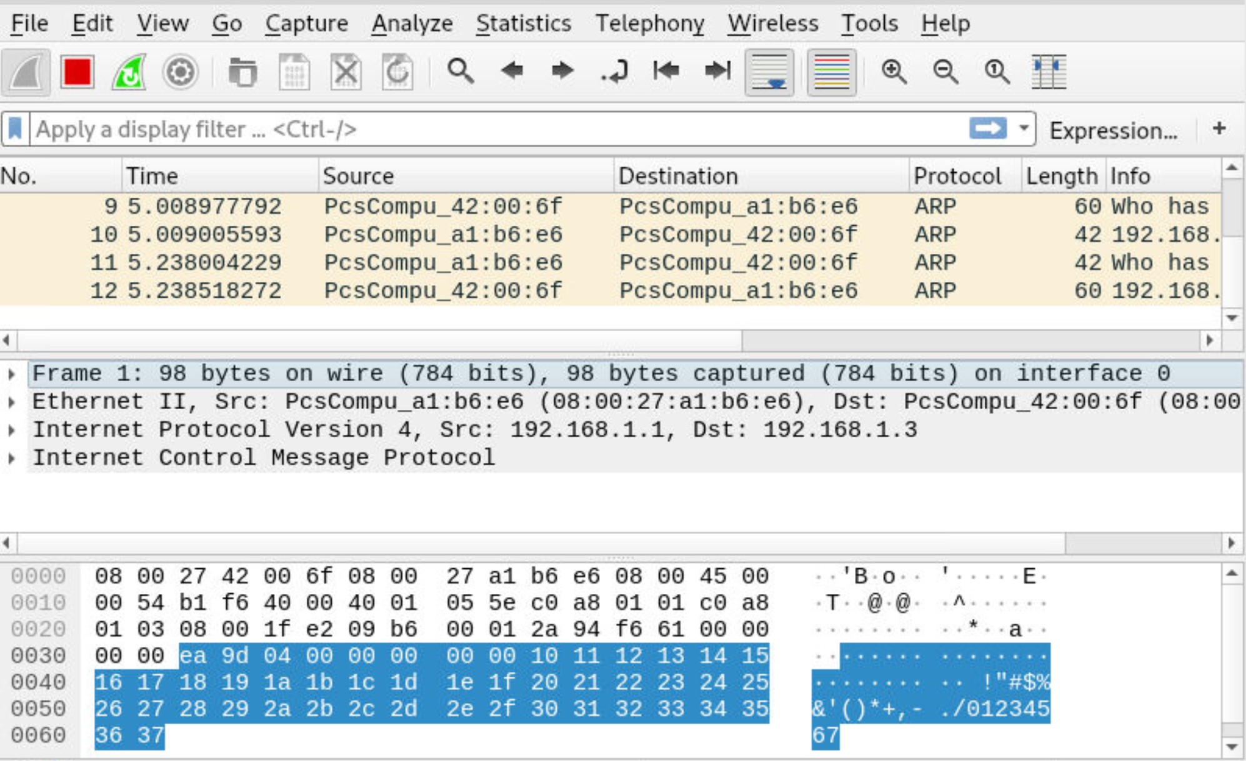

1. sudo tcpdump -I eth0 -X -> WireShark always listen with verbose On

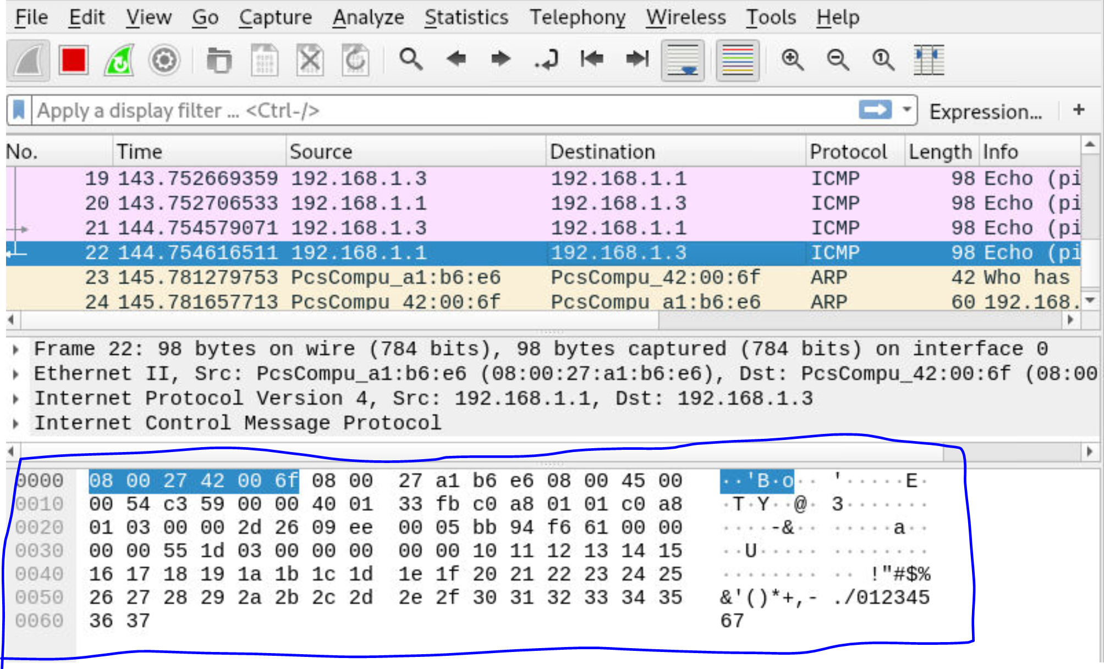

1. sudo tcpdump host 192.168.1.1 -> filter: ip.addr == 192.168.1.1

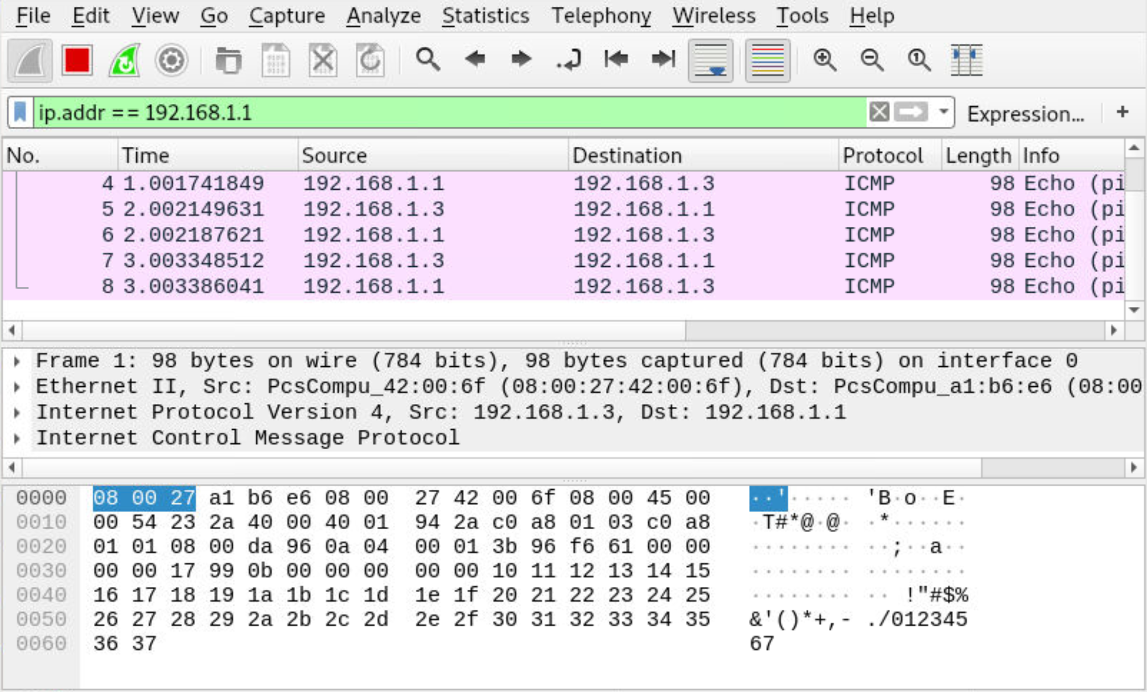

1. sudo tcpdump -i eth0 src 192.168.1.3 -> Wireshark filter: ip.src==192.168.1.1

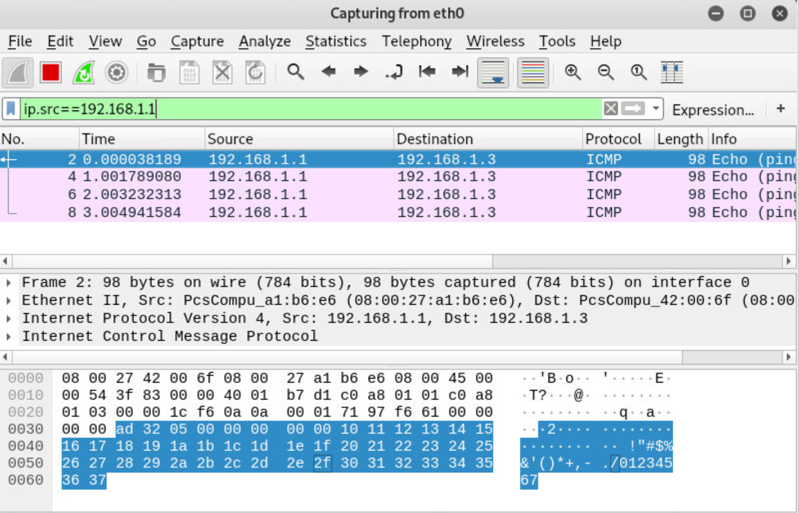

1. sudo tcpdump -i eth0 dst 192.168.1.3 -> Wireshark filter: ip.dst==192.168.1.1

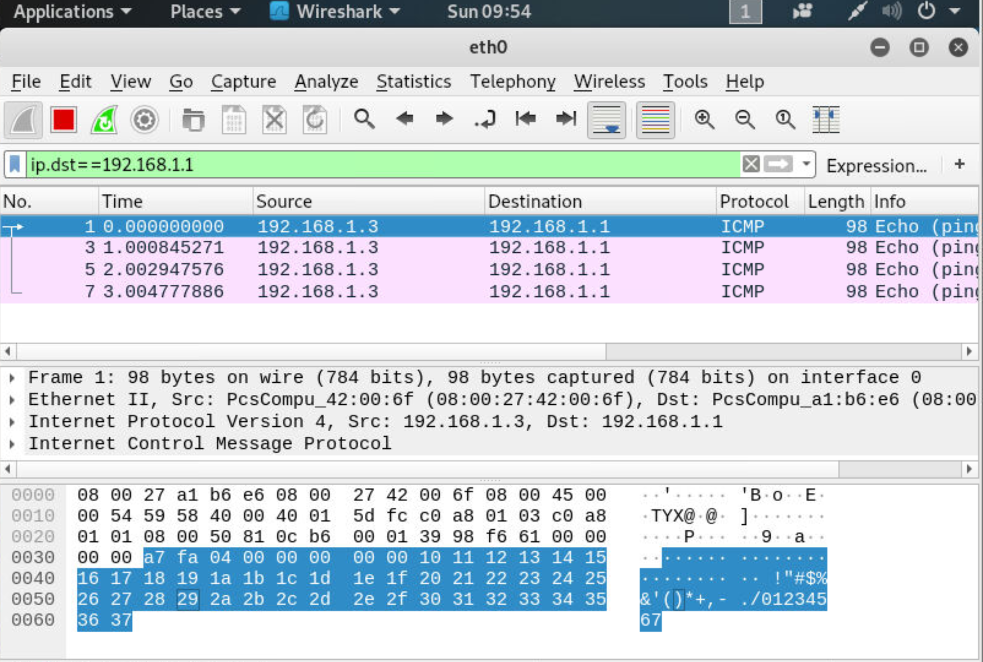

1. sudo tcpdum -i eth0 port 443 -> WireShark filter: tcp.port==443

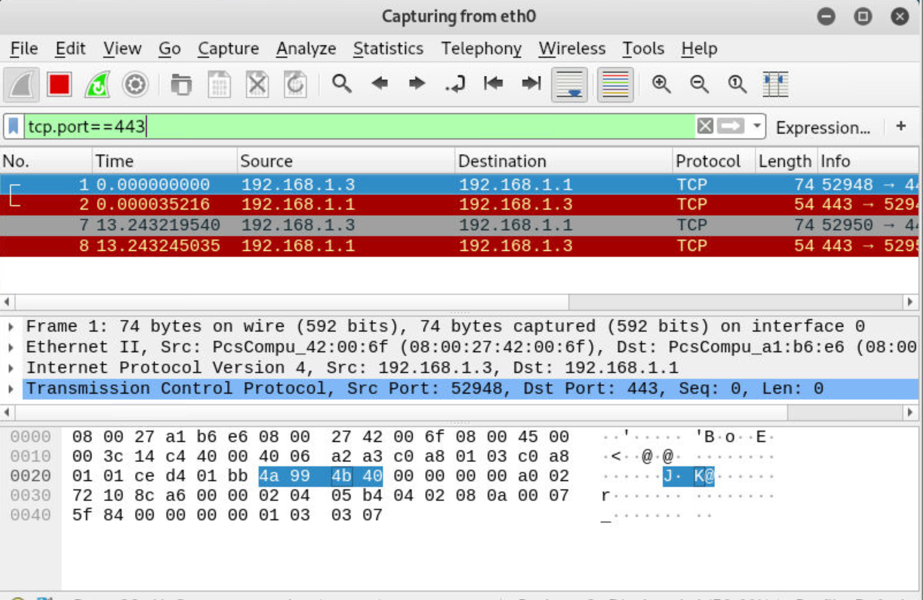

1. sudo tcpdump -i eth0 src port 443 -> Wireshark filter: tcp.srcport==443

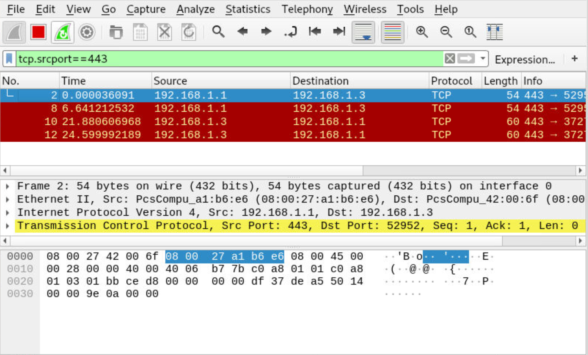

1. sudo tcpdump -i eth0 portrange 1-443

* Wireshark filter: (tcp.port > 0) or (tcp.port < 444)

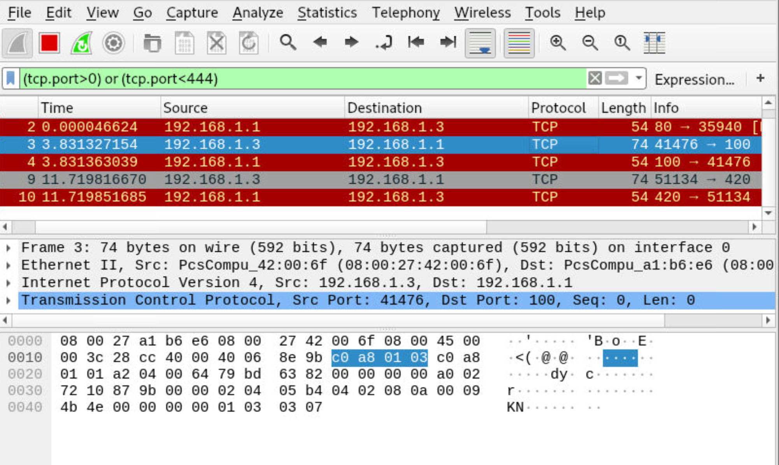

1. Sudo tcpdump -i eth0 -w test.pcap -> WireShark Save File

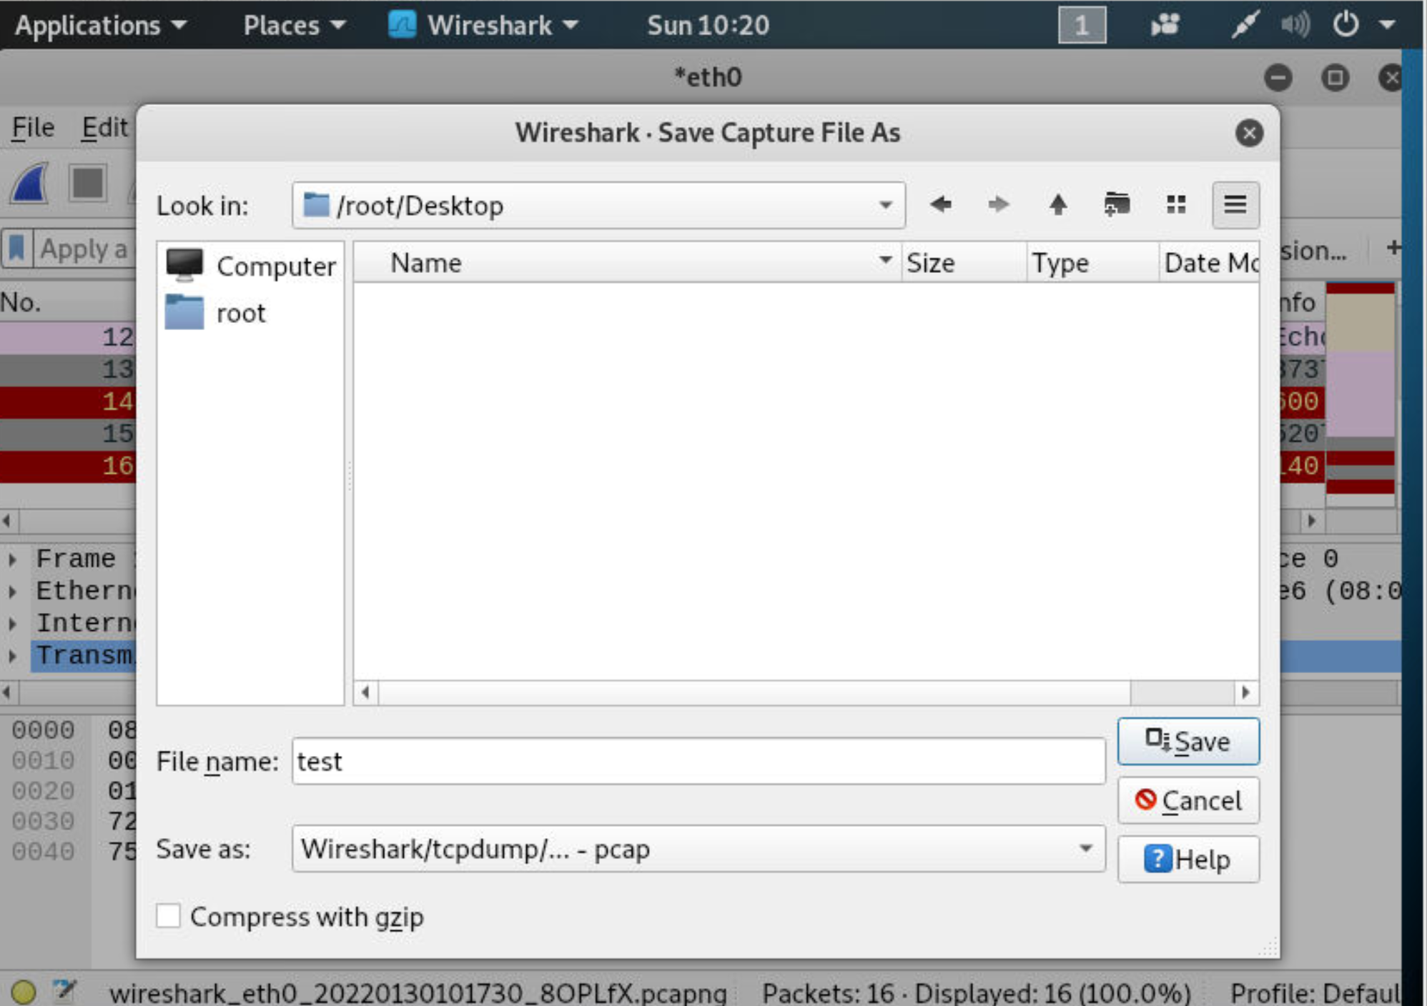

1. Sudo tcpdump -i eth0 -W 2 -C 10 -w test.pcap

* Wireshark save file as (can choose different formats and names)



1. tcpdump -r test.pcap0 -> Wireshark: Open file with wireshark

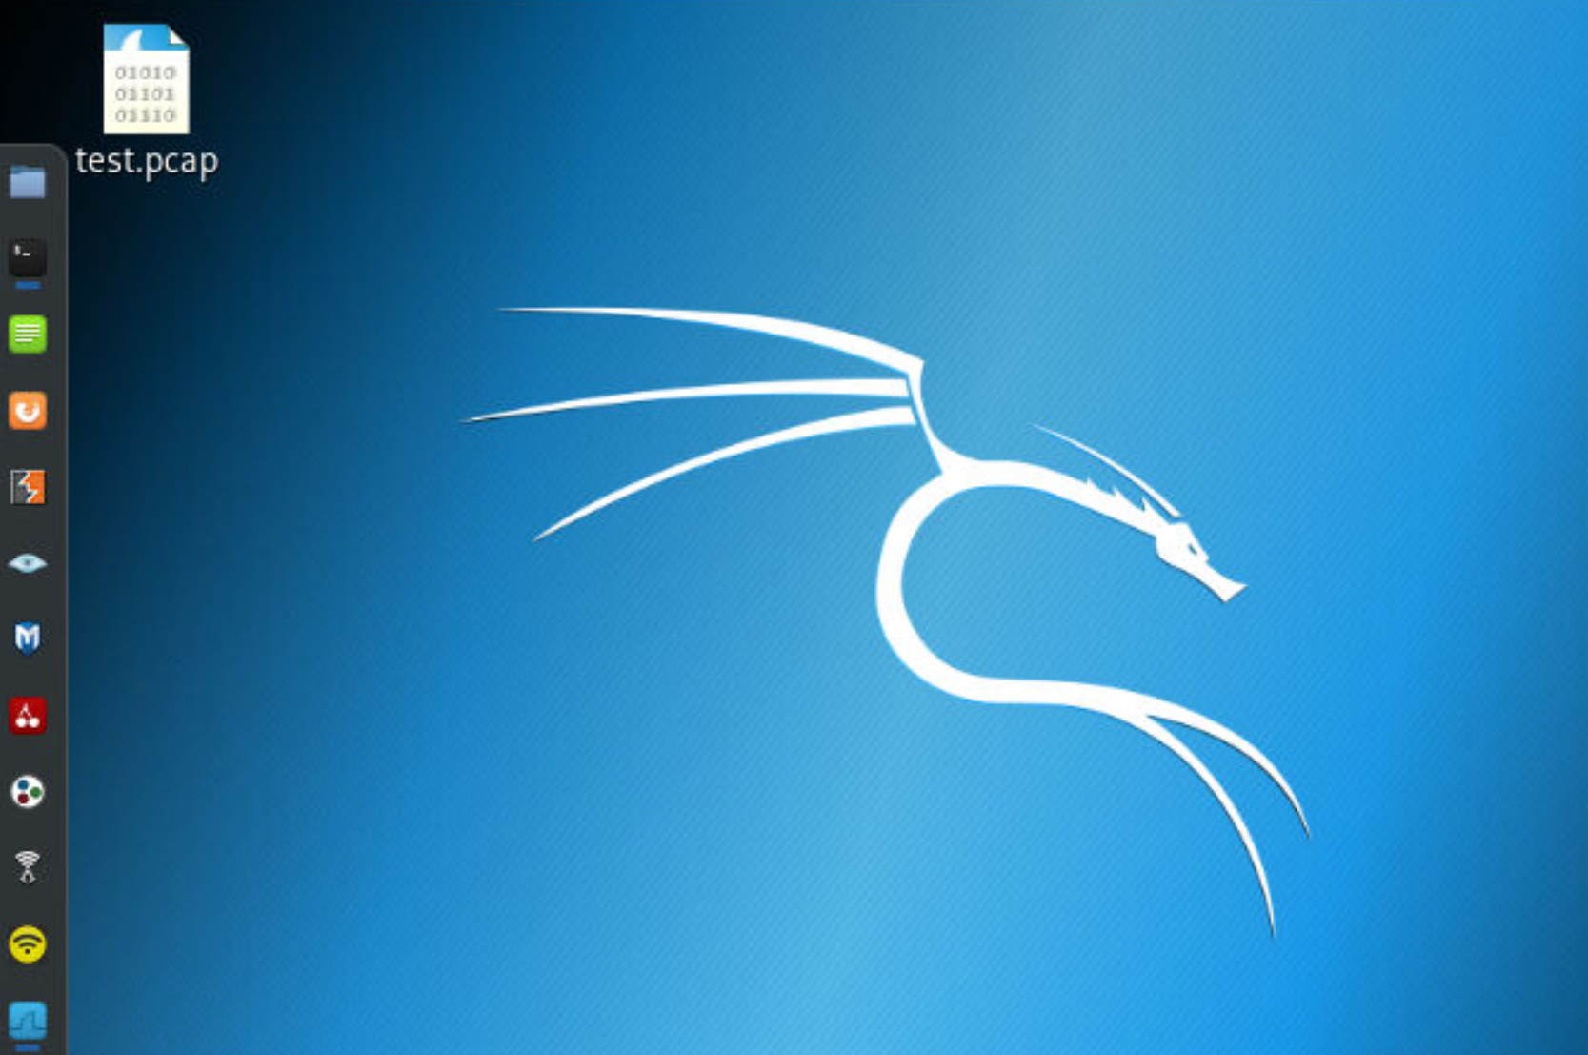

After Double Clicking on file Wiresharks opens:

